Servcing Module API
Ad-Hoc Charges Unit Test Document
May 6, 2026
tamweel aloula
KSA
Document History
Author | Version | Date | Description
Farhan Ullah Khan | V1.0 | 5th MAY 2026 | Initial Document

Table of Contents
1. Ad-Hoc Charges Mechanism 3
2. Initial Request 3
3. Rosom Bill Generation: 4
4. Payment of Rosom Bill: 4
5. Recognition of Charge: 5
6. List of Ad-doc Charges 6

Ad-Hoc Charges Mechanism
As per FSD below flow will be follow for Ad-Hoc Charges.
- Initial Request – Customer initiates request from New Digital.
- Rosom Bill Generation – Rosom bill generated if funds are not sufficient in customer repayment account.
- Payment of Rosom Bill – Customer pays bill through Rosom portal.
- Recognition of Charges – Upon recovery of funds charge will be recognized accordingly.

Initial Request
Upon initiation of request API triggers to generate Rosom bill if funds are insufficient in customer’s repayment account.
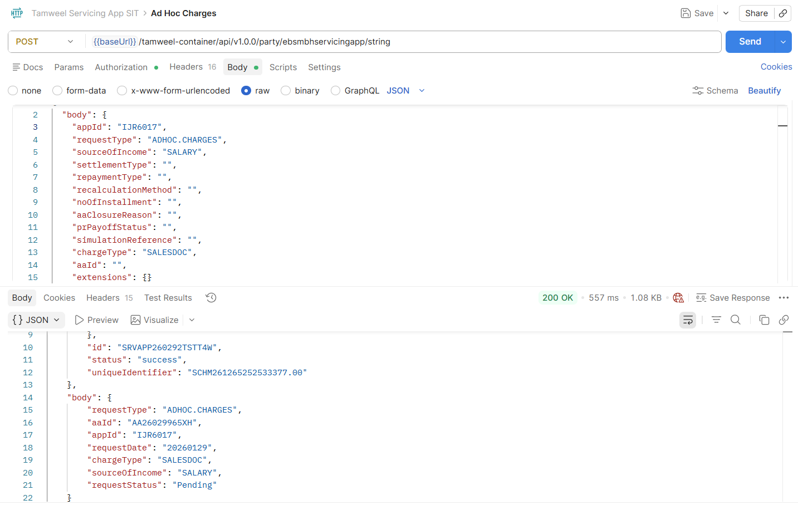

Rosom Bill Generation:
Bill template generated in transact carrying Sadad number for payment.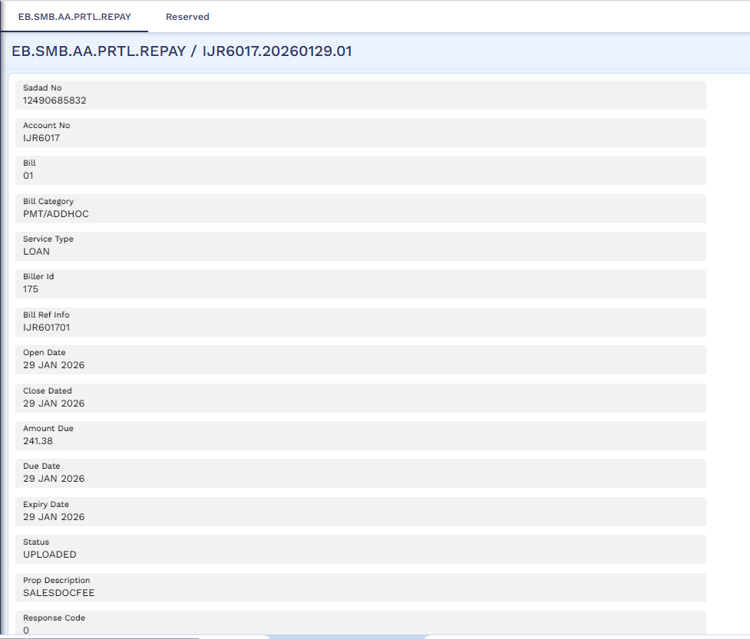

Payment of Rosom Bill:
Rosom bill generated and available on bill management portal.
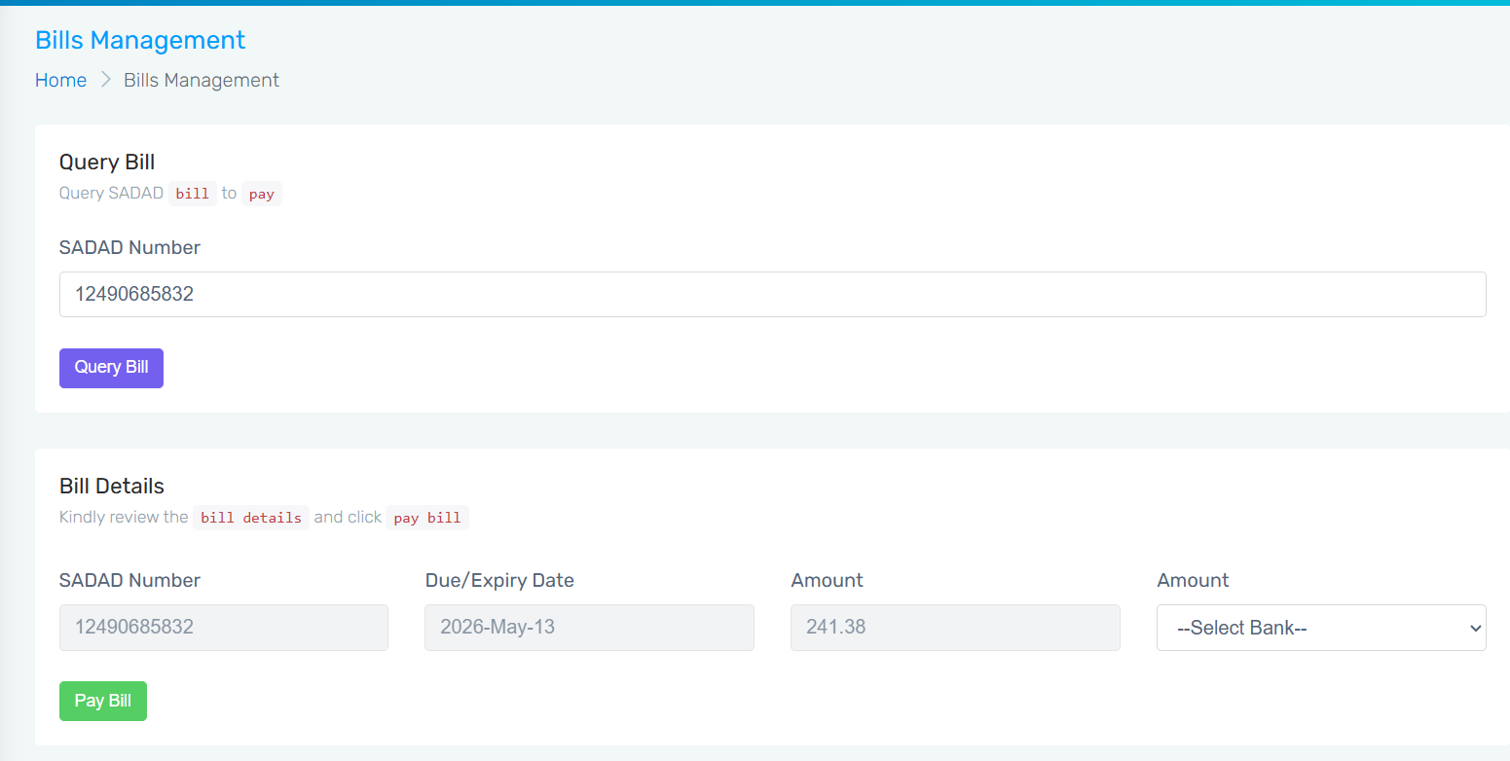

Funds credited in customer’s repayment account.
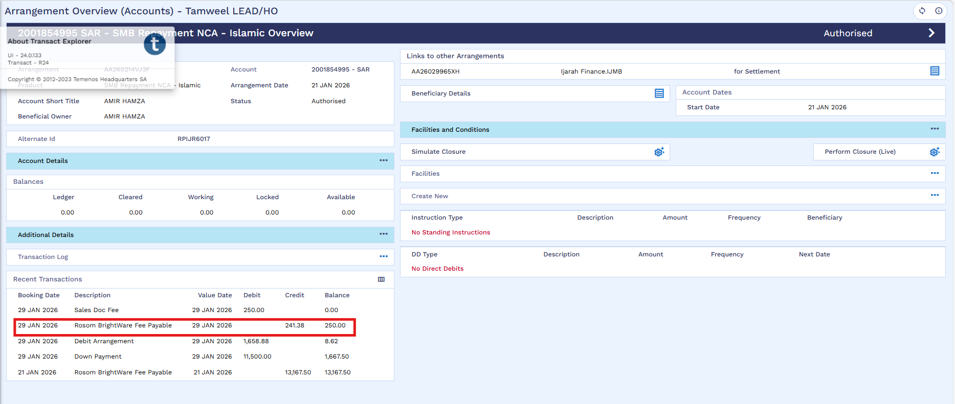

Recognition of Charge:
After recovery of Rosom bill, OFS triggers to recognize charge accordingly.
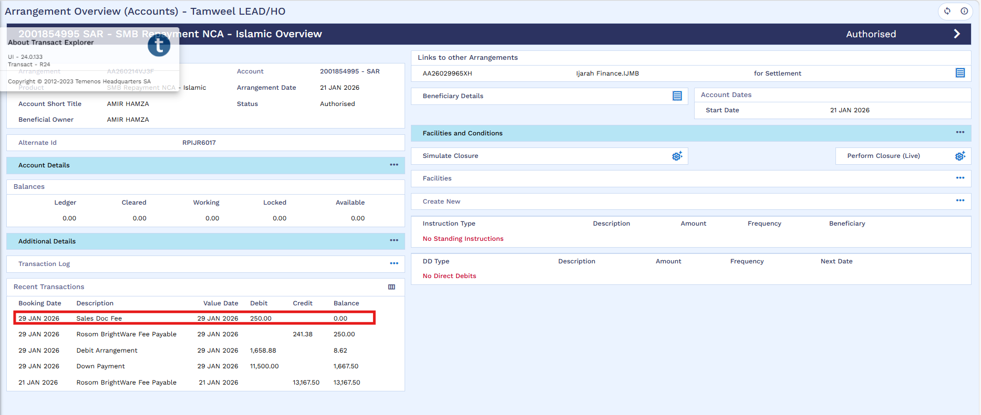
AC Charge request details
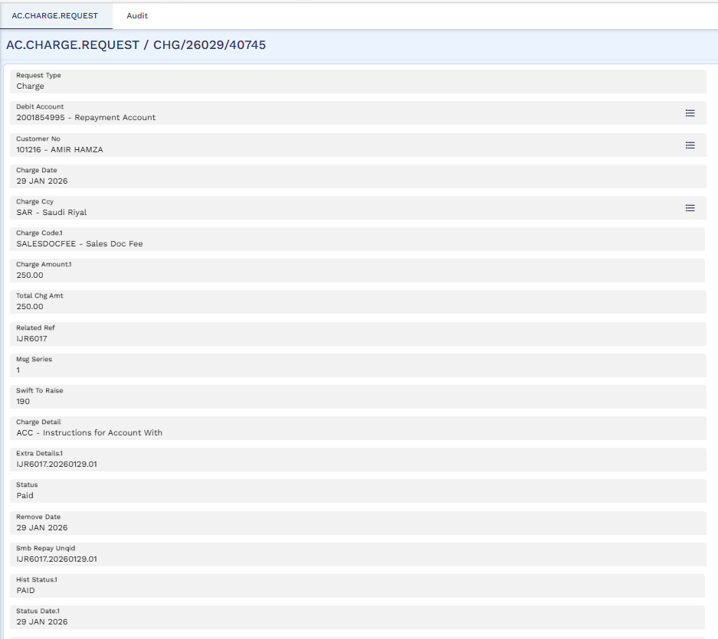

List of Ad-doc Charges
S No. | Service | Charges | FT Commission Type | Transaction Code
1 | Sales Doc | 250 | SALESDOCFEE | 2448-2467
2 | Add actual driver | 300 | ACTDRIVFEE | 2449-2466
3 | Ownership Transfer | Based on Internal Policy | OWSHTRAN | 2450-2465
4 | 3M Authorization | 50 | 3MAUTH | 2451-2464
5 | Insurance Extension (GCC) | Based on Insurance Company | INSEXTGCC | 2452-2463
6 | Insurance Extension (Jorden) | Based on Insurance Company | INSEXTJOR | 2453-2462
7 | Insurance Extension (Bahrain) | Based on Insurance Company | INSEXTBAH | 2454-2461
8 | 3M Authorization (Jorden) | 400 | 3MAUTHJOR | 2455-2460
9 | 3M Authorization (GCC) | 200 | 3MAUTHGCC | 2456-2459
10 | Borrow of Spear key | 250 | BORSPKEY | 2457-2458

